# **Problems #31 to #35**

==================================

# **Problem 31**

===================

Description: Write A Problem To Get: Power of 2,3,4

Without using any functions

=======================================

// Online C++ compiler to run C++ program online

#include <iostream>

using namespace std;

int ReadNumber(){

int N = 0;

cout<<"\nEnter Number: ";

cin>> N;

return N;

}

void PowerOf2_3_4(int Number){

int A , B , C;

A = Number * Number;

B = Number * Number * Number;

C = Number * Number * Number * Number;

cout<<A<<" "<<B<<" "<<C<<endl;

}

int main() {

PowerOf2_3_4(ReadNumber());

return 0;

}

=====================================================================

The Output:

==============

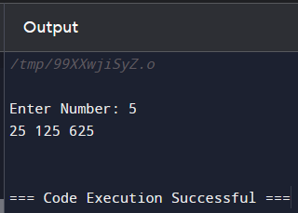

=====================================================================

# **Problem 32**

===================

// Online C++ compiler to run C++ program online

#include <iostream>

using namespace std;

int ReadNumber(){

int N = 0;

cout<<"\nEnter Number: ";

cin>> N;

return N;

}

int ReadPower(){

int P = 0;

cout<<"\nEnter The Power: ";

cin>> P;

return P;

}

int PowerOFM(int Number, int M){

if(M == 0){

return 1;

}

int P = 1;

for(int i = 1; i <= M; i++){

P *= Number;

}

return P;

}

int main() {

cout<<"he Result = "<<PowerOFM(ReadNumber(),ReadPower())<<endl;

return 0;

}

=====================================================================

The OutPut:

==========

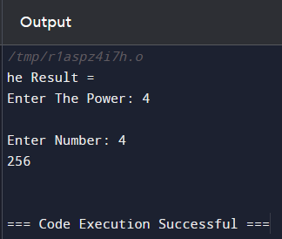

=====================================================================

# **Problem 33**

===================

Description Write A Program To Get: Grade A, B,C,D,E,F;

===========================================

// Online C++ compiler to run C++ program online

#include <iostream>

using namespace std;

int ReadNumberInRange(int From,int To){

int Grade ;

do{

cout<<"Please Enter A Grade Between 0 and 100: "<<endl;

cin>> Grade;

}while(Grade < From || Grade > To);

return Grade;

}

char GetGradeLetter(int Grade){

if(Grade >= 90)

return 'A';

else if(Grade >= 80)

return 'B';

else if(Grade >= 70)

return 'C';

else if(Grade >= 60)

return 'D';

else if(Grade >= 50)

return 'E';

else

return 'F';

}

int main() {

cout<<GetGradeLetter(ReadNumberInRange(0,100));

return 0;

}

=====================================================================

The Output:

=========

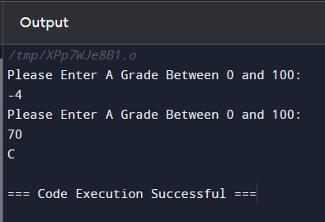

=====================================================================

# **Problem 34**

===================

Description: Write A Program To Get: Commission Percentage

=============================================

// Online C++ compiler to run C++ program online

#include <iostream>

using namespace std;

int ReadTotalSales(){

int TotalSales= 0;

cout<<"Enter Total Sales: ";

cin>> TotalSales;

return TotalSales;

}

float GetComissionPercentage(float TotalSales){

if(TotalSales >= 1000000)

return 0.01;

else if(TotalSales >= 500000)

return 0.02;

if(TotalSales >= 100000)

return 0.03;

else if(TotalSales >= 50000)

return 0.05;

else

return 0.00;

}

float CalculateTotalComission(float TotalSales){

return GetComissionPercentage(TotalSales) * TotalSales;

}

int main() {

float TotalSales = ReadTotalSales();

cout<<endl<<"Comission Percentage = "<<GetComissionPercentage(TotalSales)<<endl;

cout<<endl<<"Total Comission = "<< CalculateTotalComission(TotalSales)<<endl;

return 0;

}

=====================================================================

The output;

==========

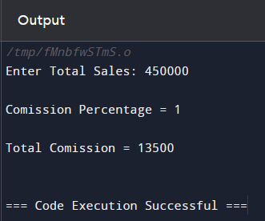

=====================================================================

# **Problem 35**

===================

Description: To Get: Piggy Bank Calculator;

=====================================================================

#include <iostream>

using namespace std;

struct stPiggyBankContent{

int Pennies, Nickles, Dimes,Quarters,Dollars;

};

stPiggyBankContent ReadPiggyBankContent(){

stPiggyBankContent PiggyBankContent;

cout<<"\nEnter The Total Pennies: ";

cin>>PiggyBankContent.Pennies;

cout<<"\nEnter The Total Nickles: ";

cin>>PiggyBankContent.Nickles;

cout<<"\nEnter The Total Dimes: ";

cin>>PiggyBankContent.Dimes;

cout<<"\nEnter The Total Quarters: ";

cin>>PiggyBankContent.Quarters;

cout<<"\nEnter The Total Dollars: ";

cin>>PiggyBankContent.Dollars;

return PiggyBankContent;

}

int CalculateTotalPennies(stPiggyBankContent PiggyBankConten){

int TotalPennies = 0;

TotalPennies = PiggyBankConten.Pennies * 1 +

PiggyBankConten.Nickles * 5 +

PiggyBankConten.Dimes * 10 +

PiggyBankConten.Quarters * 25 +

PiggyBankConten.Dollars * 100;

return TotalPennies;

}

int main(){

int TotalPennies = CalculateTotalPennies(ReadPiggyBankContent());

cout<<endl<<"Total Pennies = "<<TotalPennies<<endl;

cout<<endl<<"Total Dollars = "<< (float)TotalPennies /100<<endl;

return 0;

}

=====================================================================

TheOutput:

============



